1. April 5th Midnight

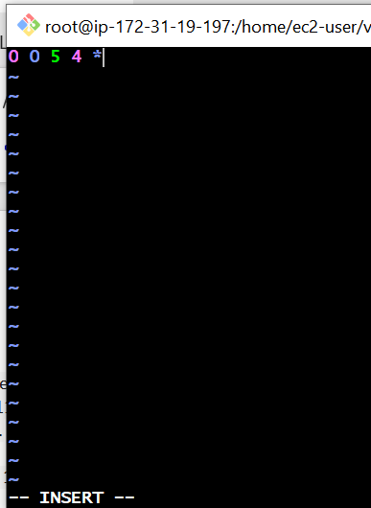

The above picture shows   
0- indicates the minutes  
0-indicates the hours  
5-indicates the date

1. indicates the month

\*-indicates the week

 2) 5 th of Every November,Jan,June if it is a Thursday.

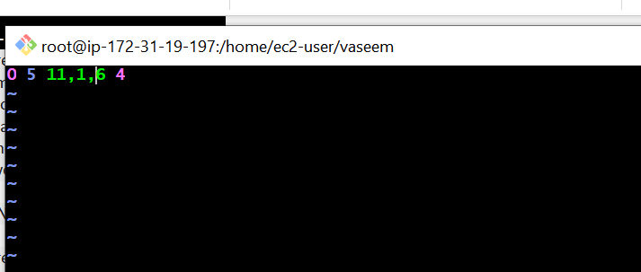

The above picture shows   
0- indicates the minutes  
5-indicates the date

11, 1, 6 indicates the months and 4 is thursday

\*-indicates the week

3) At 05 and 27th minutes of 9,10,11 hours everyday.

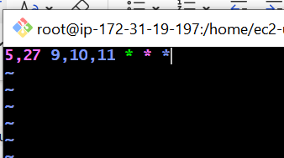

The above picture shows   
5,27- indicates the minutes  
9,10,11 indicates the hours

\* \* \*indicates the date, month, week

4) 34 min. of 9th hour on 15th Aug.

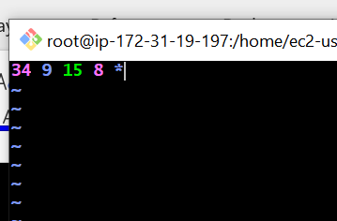

The above picture shows   
34- indicates the minutes  
9-indicates the hours

1. indicates the date
2. Indicates month

\*-indicates the week

5) Every midnight

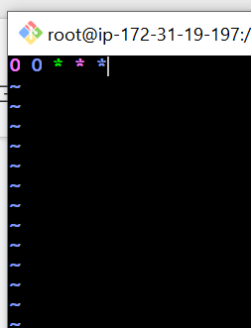

The above picture shows   
0- indicates the minutes  
0-indicates the hours

\*-indicates the date

\*-Indicates month

\*-indicates the week  
6) Every Weekend ( Saturday night 11.59 )

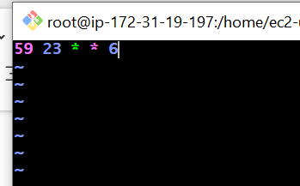

The above picture shows   
59- indicates the minutes  
23-indicates the hours

\*-indicates the date

\*-Indicates month

1. indicates the day  
     
   7) After every reboot

